AWS SECRETS MANAGER
AWS Secrets Manager is a security service designed to protect the "secrets" your
applications use to access resources, such as database credentials, API keys, and
OAuth tokens.
Instead of hard-coding sensitive information directly into your source code
(which is a major security risk), you store those credentials in Secrets Manager
and retrieve them programmatically at runtime.
Example :
Suppose an application connects to a MySQL database.
Instead of storing:
username=admin
password=Admin123
inside the code,
the credentials are stored securely in Secrets Manager.
Scenario
An e-commerce web application connects to a production MySQL database.
The application requires:
- database username
- password
Without Secrets Manager, developers may store credentials directly inside
application code.
Click on store a new secret
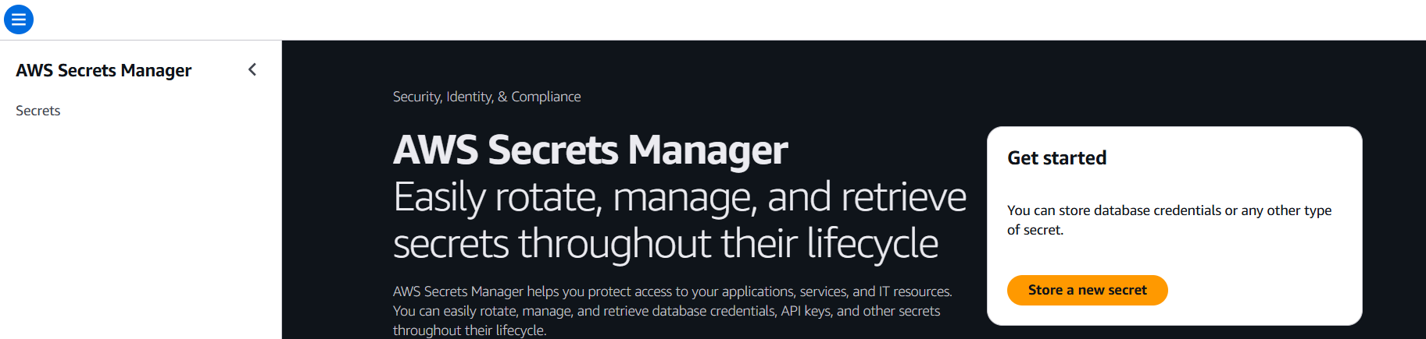

Assign key/value—In this I am giving username and password
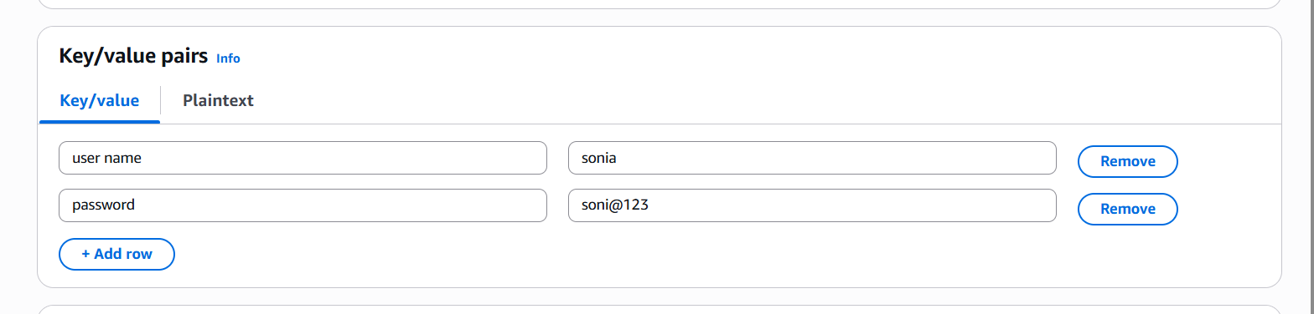
Given a secret name
